Specifications
Pauselli 700 solar machine with screw pile drive unit.
Ideal for photovoltaic installation the Pauselli 700 Model is stable, compact and quick. It is specially designed for solar piles, managing tasks with unbelievable ease. This flexible machine is also capable of both hammering in and screwing in solar piles, giving you added alternatives.

This model can be fitted with GPS / laser machine control equipment, which precisely locates piles to +/- 10mm for location and height +/- 3mm, increasing accuracy and efficiency. The adaptable Pauselli 700 can install piles up to 3.1m long but on request the machine can be supplied with extension columns which will install piles 3.5 or 4m high.
Manufactured to the highest possible standards the Pauselli 700 comes with a 12 month (1000 hours) warranty, making it the best choice for the demands of solar pile driving. Our specialised and experienced team at Groundworks are here to support you from purchase, supply of parts and technical support right throughout the life of the machine.

For further information and full specifications please contact us.

Machine Specifications

STANDARD EQUIPMENT
Bridgestone rubber tracks
DEUTZ diesel engine, air cooled, 3 cylinders, kW 36.3 (HP 48) @ 2.600rpm
Hydraulic hammer, INDECO Mod. HP 700 (weight 440–620 kg (970–1367lb) to 1500 beats / min – 830joules)
Machine positioning, Danfoss proportional modular distributor through 9 levels
Hydrostatic system with cast iron pump and flow rate
120L (31.7 gal)/min @190 bar
Hydraulic oil heat exchanger
Hydraulic oil tank capacity 200L (52.8 gal) and level indicator
Diesel oil tank capacity 100L (26.4 gal)
Column inclination both transverse and longitudinal +/- 15
Maximal horizontal slide movement column 700mm (2.3’)
Lateral column movement +/- 280mm (11”)
Extractable supporting foot on column base to allow safe pile extraction
Reversible post guide on column, driving the post in both directions
Maximum post dimension: 160 x 120mm (6.3” x 4.7”)
Maximum post height: 3.1m (10’)
Homologated chain for machine loading and unloading
Homologated chain for pile extraction
Hammerhead and template mounted on machine
Transport dimensions 2m x 2.28 x 2.28m (height) (6.5’ x 7.5’ x 7.5’)
Weight 2.95 tonne (3.25 ton)
OPTIONAL:
Double extensible column up to 4.1m (13.5’) or
Folding extensible column, maximum extension 3.5m (11.5’)
Rotational head 100mm (3.9”) (120rpm , torque: 160 kgm)
DTH hammer rock drill
Fast and efficient automatic mast leveling
Kubota liquid cooled diesel engine, 4 cylinders, 36.5 kW
Synergy GPS Positioning System
Training by highly experienced civil engineers worldwide

MOD. 700

r  TECHNICAL DATA | UNIT | "'  VALUE
DIESEL ENGINE DEUTZ D201 1 L03 AIR-Oll COOLED, 3 CYLINDERS | kW - (hp) | 36,3 - (48)
HYDRAULIC HAMMER INDECO HP 700 - IMPACT ENERGY | Joule | 830
HAMMER WEIGHT | kg | 440
STRIKING RATE PER MINUTE | n/min | 620 -1.500
POST DRIVING CAPACITY | mm | 160 X 120 X 3.100h
MAX NOISE | dBA | 75
HYDRAULIC Oll TANK CAPACITY | 1 | 200
DIESEL TANK CAPACITY | 1 | 100
SPEED | km/h | 7
TRANSPORT DIMENSION | mm | 2.000X2.200X2.200h
TOTAL WEIGHT | kg | 2.950
OPTIONALS:
DIESEL KUBOTA ENGINE MOD. V2403/M WATER COOLED, 4 CYLINDERS, kW 36,5 (hp 48,9)
FOLDING EXTENSIBLE COLUMN, MAX. EXTENSION UP TO 3.500 mm
TOTAL WEIGHT OF THE MACHINE, INCLUDING THE FOLDING COLUMN: 3.100 kg
...

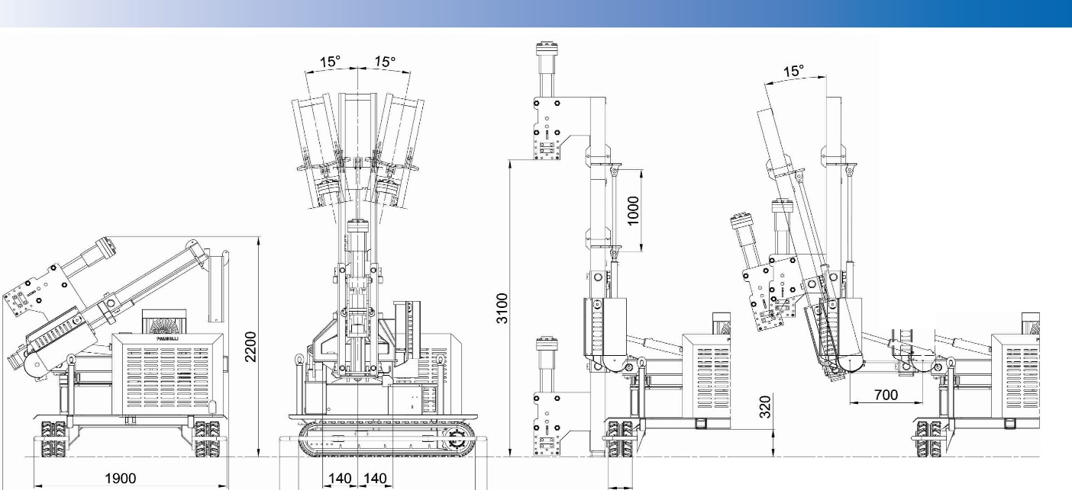
n
1 1

1 1

LD
H I 1 I

1 | 1 11
1 | 1 11
1 | 1 1 1  l lL

2200 1750

m

250

m

2000 m

